
Tuesday’s 1:00 – 2:00
Year 8 History work pack
The Black Death
All tasks are highlighted in blue
Guidance for writing is in purple
Answer booklet for parents is separate.

Context of work pack: This work pack will enable pupils to reflect and build on their knowledge of the Black Death, a major disease that spread throughout the world. Although pupils have previously looked at the Black Death in school, it is a good opportunity to practice using sources and reading comprehension as these are vital skills for historians. Having a dictionary or online dictionary may also be helpful. The Black Death will appear again in GCSE History when studying medicine so understanding the way people were treated and tried to prevent the disease will be beneficial later in their school life.
Questions for parents to support
Why caused the Black Death? Which country did it come from?
How did it spread across Europe?
What did people believe caused it at the time?
What are some symptoms of the Black Death?
What are the three plagues that people could get?
What are some treatments people tried? Were they affective?
How did the Black Death affect life afterwards?
Lesson 1 – Origins of the Black Death
LO: To identify where the Black Death originated from and how it spread across Europe

Background information:
The Black Death is another name for the bubonic plague. The plague was a dreadful illness that across Asian and Europe in the mid-1300s. People who caught the disease normally died within a week.
The plague arrived in Europe in October 1347, when 12 ships from the black sea docked at the Sicilian port of Messina. People who gathered on the docks were met with a horrifying surprise: most sailors aboard the ships were dead, and those still alive were gravely ill and covered in black boils that oozed blood and pus. Sicilian authorities hastily ordered the fleet of “death ships” out of the harbour, but it was too late: over the next five years, the Black Death would kill more than 20 million people in Europe – almost one-third of the continent’s population. So what caused this so called ‘Black Death’ and how did it spread and kill so many?

Key Vocabulary
Bubonic Plague: a very infectious disease spread by rats, causing swelling, fever, and usually death. In the 14th century, it killed half the people living in Europe.
Origin/Originated- the point or place where something begins
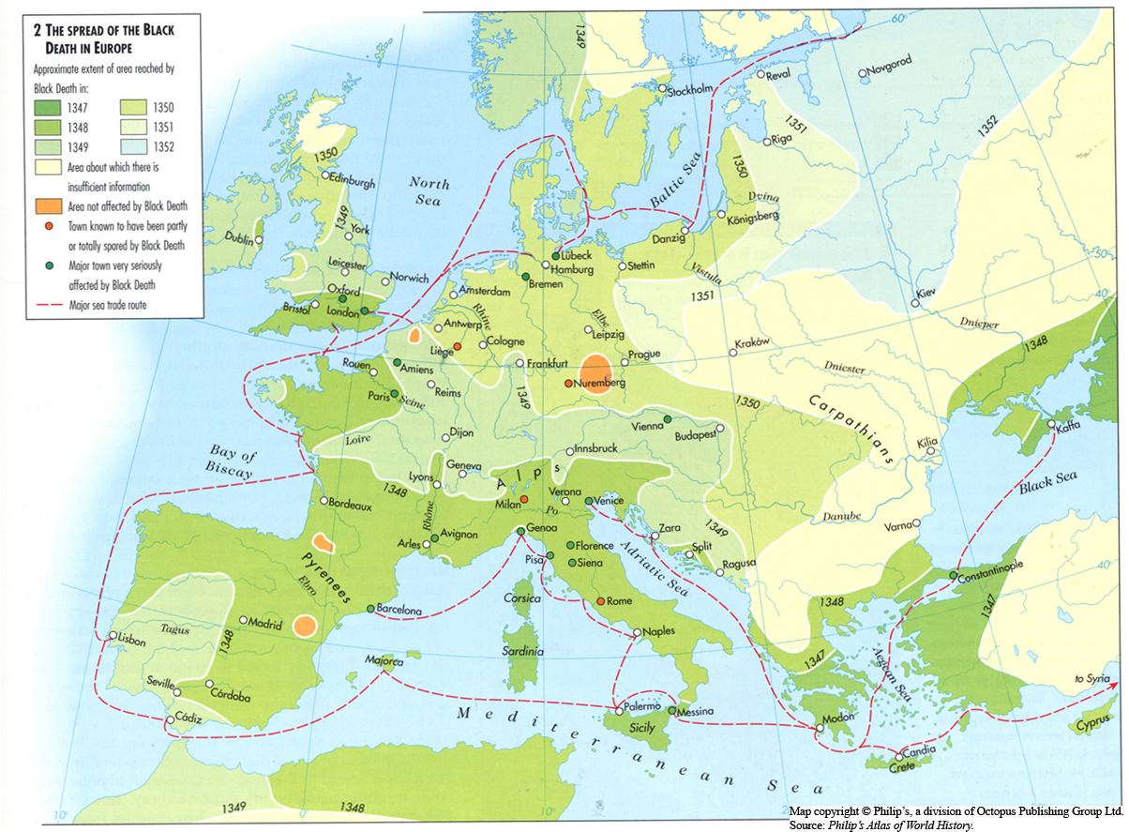

Brain dump – Mind-map everything you can remember about the Black Death from school lessons.

Task 1: Using the map above mind – map what it shows about the spread of the Black Death
Questions to think about:
- Which countries were affected first?
- How did the disease spread? (Think about how they may have travelled)
- Is there a pattern that suggests which countries were affected the worst?

Task 2: Read through the information and answer the questions below
Even before the “death ships” pulled into port at Messina (Italy), many Europeans had heard rumours about a “Great Pestilence” (plague) that was carving a deadly path across the trade routes of the Near and Far East. Indeed, in the early 1340s, the disease had struck China, India, Persia, Syria and Egypt. Historians think the plague began in Central Asia, possibly in China, and spread throughout China, India, the Middle East, and then Europe. The disease travelled from Central Asia to the Black Sea along the Silk Road (the main trade route between Asia and the Mediterranean Sea). It probably was carried to Italy on a ship. It then spread north and west, throughout the continent of Europe and to England.
Which country did the Black Death hit first?
______________________________________________________________________________________________________________________________________________________
Where do historians believe the disease originated?
______________________________________________________________________________________________________________________________________________________
How did the disease spread?
______________________________________________________________________________________________________________________________________________________
What was another name for the Black Death was the?
Bubonic Plague | Puponic Blague | Pneumonic Plague
What year did the Black Death hit Europe?
1447 | 1557 | 1347
Where did the disease come from and how did it spread?
China and through the trade routes | Russia and through the trade routes | Africa and through the trade routes
Who caught the disease first?
Children | Miners | Sailors
Task 3: Reflect - Complete the Multiple choice questions

Task 4: Using the timeline label the map below.
Things to include: Dates, names of countries and how the Black Death spread to each area. Draw arrow to show the movement of the disease.
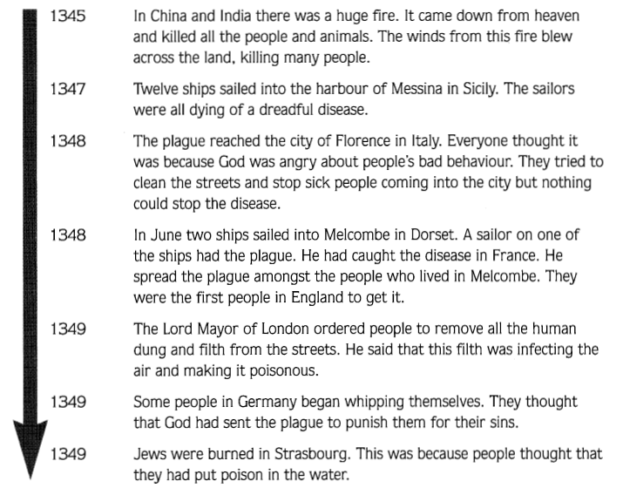
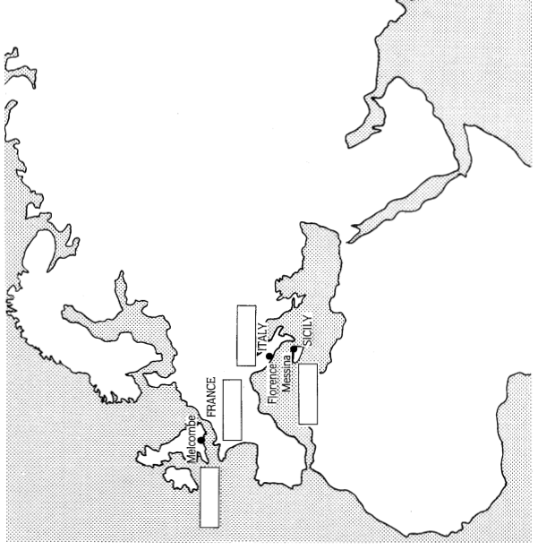
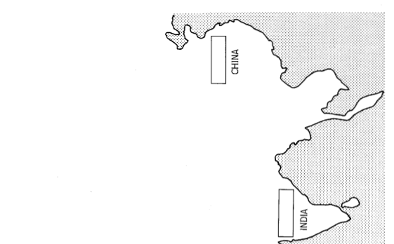

Task 5: Imagine you are a scientist, a traveller or a sailor observing the spread of the Black Death. Your task is to create a journal/diary extract explaining where the Black Death originated from and how it spread across to Europe

________________________________________________________________________________________________________________________________________________________________________________________________________________________________________________________________________________________________________________________________________________________________________________________________________________________________________________________________________________________________________________________________________________________________________________________________________________________________________________________________________________________________________________________________________________________________________________________________________________________________________________________________________________________________________________________________________________________________________________________________________________________________________________________________________________________________________________________________________________________________________________________________________________________________________________________________________________________________________________________________________________________________________________________________________________________________________________________________________________________________________________________________________________________________________________________________________________________________________________________________________________________________________________________________________________________________________________________________________________________________________________________________________________________________________________________________________________________________________________________________________________________________________________________________________________________________________________________________________________________________________________________________________________________________________________________________________________________________________________________________________________________________________________________________________________________________________________________________

Review: summarise what you have learnt in today’s lesson by adding to you “Brain dump” at the start of the lesson using a different colour pen if you can. If there is anything you are not sure on you can write some questions below and email them to your teacher for more help.

Lesson 2 – Causes and Symptoms
LO: To describe features of the Bubonic plague by looking at the causes and symptoms

Background information:
From last lesson, we learnt that the Black Death was spread through trading ports and was bought to the Europe through ships whilst they traded goods. But what actually passed the disease from one person to the other?
There were three types of plagues, the Bubonic plague, pneumonic plague (this attacked the lungs. Victims died quickly, in one or two days) and the septicaemic Plague (this infected the blood). The Bubonic plague was the most common at the time. It often caused large swellings as the body fought the disease. To catch this type of plague you had to be bitten by a flea that had already bitten a black rat. The fleas would suck blood from the black rats and then suck the blood from humans, which transferred over the germs, and bacteria that caused the plague.

Key Vocabulary
Symptom - a physical or mental feature that shows that a person has an illness or a disease.
Example: Symptoms for a cold are a runny nose, sneezing, fever etc.

Brain dump – Mind-map everything you can remember from last lesson, check your work before moving on.

Task 1: Put the cards below in chronological order and then using the cards label the diagram below to see how humans caught the Black Death and how it spread. One has been done for you
Fleas would suck the blood of the rats. | The fleas infected other rats and humans with the plague. Soon almost half the people in England were dead. | The flea would pass on the plague germs to the human, which would make them ill and eventually kill them.
When the human died, the flea jumped onto another rat or human. The flea would bite another human. | The plague germs lived in the blood of a rat. This made the rats very sick. | When the rats died, the fleas jumped onto humans and would bite the humans to suck on their blood.

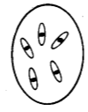
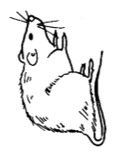
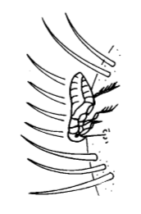
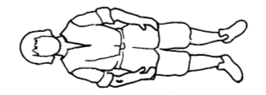
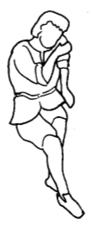
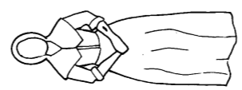
The plague came from germs called pasteurella pests.
________________________________________________________________________________________________________________________________________________________________________
________________________________________________________________________________________________________________________________________________________________________
__________________________________________________________________________________________________________________________________________________________________________________________
________________________________________________________________________________________________________________________________________________________________________
________________________________________________________________________________________________________________________________________________________________________
________________________________________________________________________________________________________________________________________________

Above you can see what actually caused the Black Death however, during this period people did not have understanding of germs and diseases and also did not know what was causing the disease therefore people had varying beliefs as to what caused it.
Task 2: Using the sources write down one thing that you can infer about what people believed caused the disease.
Source A by a Medieval Italian writer
‘In Christian Europe, people believed that the plague was punishment from God for the sins of all Christians’.
One thing I can infer from source A is:
______________________________________________________________________________________________________________________________________________________________________________
I know this because within the source it states:
______________________________________________________________________________________________________________________________________________________________________________

Source B: From a book written in 1349
‘In many German cities, Jews were thought to have caused the death by poisoning the water supply. Many Jewish men, women and children burned to death for this’.
One thing I can infer from source B is:
______________________________________________________________________________________________________________________________________________________________________________
I know this because within the source it states:
______________________________________________________________________________________________________________________________________________________________________________

Source C: Based on a report written by doctors at Paris University in 1348.
‘The long term cause is the position of the planets. It is also caused by evil smells which mix with the air and spread on the wind. When you breathe in the corrupted air you can catch the plague’.
One thing I can infer from source C is:
______________________________________________________________________________________________________________________________________________________________________________
I know this because within the source it states:
______________________________________________________________________________________________________________________________________________________________________________Task 3: Now that you know how the disease spread from fleas/rats to humans, let’s look at the symptoms. Using the symptom cards answer the questions below and label the diagram.
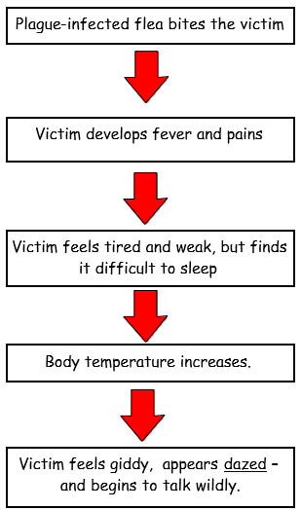
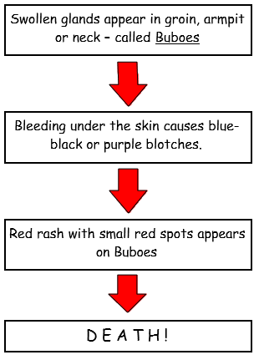

Key Words
Symptoms – the signs of having an illness Dazed – not being able to think properly Buboes – swollen lumps (a bit like boils) in the groin, neck or armpit

Above you can see all the symptoms of the plague, from when the flea bites the victim until the victim dies. A person suffering from Bubonic Plague may die within 4 to 7 days of first showing symptoms. The plague killed 50%-75% of its victims.

Questions
How did a person get the disease? ______________________________________________________________________________________________________________________________________________________
How long did it take to die from the plague? ______________________________________________________________________________________________________________________________________________________
What percentage of victims often died from the plague?
______________________________________________________________________________________________________________________________________________________
Label/draw the different symptoms of the plague on the diagram below. Make sure to number each stage. One has been done for you.
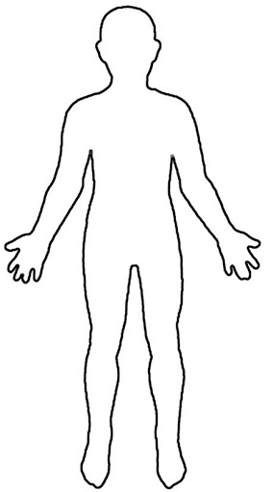
Plague-infected flea bites the victim

Task 4: Reflect - Complete the Multiple choice questions
What is the correct definition for symptom?
a physical or mental feature which shows that a person has an illness or a disease. | a physical or mental feature which shows that a person is fit and well | a physical or mental feature which indicates that a person is cured from a disease
What was the Black Death caused by?
A mouse and an ant | A black rat and a flea | A black rat
How many types of plagues were there?
3 | 4 | 5
What are some symptoms of the Bubonic Plague?
Swollen glands called buboes | High fever as body temperature increases | Bleeding underneath the skin

Task 5: Describe two features of the Bubonic Plague (this can include symptoms or causes)
Identify first feature:
_________________________________________________________________________________________________________________________________________________________________________________________________________________________________ Describe the feature by adding detail:
____________________________________________________________________________________________________________________________________________________________________________________________________________________________________________________________________________________________________________
Identify second feature:
_________________________________________________________________________________________________________________________________________________________________________________________________________________________________
Describe the feature by adding detail:
____________________________________________________________________________________________________________________________________________________________________________________________________________________________________________________________________________________________________________
Review: summarise what you have learnt in today’s lesson by adding to you “Brain dump” at the start of the lesson using a different colour pen if you can. If there is anything, you are not sure on you can write some questions below and email them to your teacher for more help.

Lesson 3 – Treatments
LO: To describe the different cures and treatments people tried to get rid of the Black Death

Background information:
From last lesson, we learnt what caused the Black Death, the causes that people believed at the time and the symptoms people developed once they got the disease. Within this lesson we will be looking at the different types of cures/treatments people tried to get rid of the disease.
In the 1347 - 1350 outbreak, doctors were completely confused about the Black Death and were desperate to find a cure. Therefore, a number of them tried a range of different cures as they were getting desperate to be rid of this deadly disease. Examples of the treatments were 'Blood-letting’ – deliberately bleeding of a vein to try and reduce 'hot’ blood, whilst blowing your nose or clearing your throat was a way of getting rid of too much ‘cold’ phlegm. Mustard, mint sauce, apple sauce and horseradish were used to balance wet, dry, hot and cold in your diet! These were only a few of the unusual remedies tried.

Key Vocabulary
Treatment - the use of drugs, exercises, etc. to improve the condition of an ill or injured person, or to cure a disease.

Brain dump – Mind-map everything you can remember from last lesson, check your work before moving on.

Task 1: Using the sources complete the table below looking at the different treatments people tried and how effective they were
Source 1:  - People were encouraged to carry a bunch of herbs and hold it to your nostrils at all times.  - People burned sweet-smelling wood in their houses to mask the bad smell.  - People did not go near stagnant (still) water, slaughter houses or rubbish heaps. | Source 2:  - The sick were forced to leave the village  - Those that were infected were locked up in their houses  - Some even ran away such as The Bishop of Winchester. | Source 3:  - People were encouraged to bury or burn the clothes of the plague victims.
Source 4:  - The disease must be in the blood. The veins leading to the heart should be cut open and bled. This was called blood-letting. This will allow the disease to leave the body. An ointment made of clay and violets should be applied to the place where the cuts have been made. | Source 5:  - People prayed to God and asked him to forgive them  - In London people walked through the streets singing hymns and whipping each other to show how sorry they are  - Thousands of people went on pilgrimages to Canterbury , Walsingham and other holy places | Source 6:  - Victims of the Black Death would often be bathed in urine several times a day to relieve the symptoms of the plague.  - The buboes (sores) were cut open, and a paste was applied. The paste was made from a mixture of tree resins, flower roots, and poo.  - If a person gets the disease, they must be put to bed. They should be washed with vinegar and rose water.

Source | Describe the treatment or cure | Why did people think this would work? | How likely is this actually going to help? (0-5) Explain your reasoning
1
2
3
4
5
6

Task 2: Reflect - Complete the Multiple choice questions
What was an example of the cures that doctors tried at the time?
Cutting the skin to bleed the disease out | Drinking the blood of others | Eating the flesh of a victim
Why did Doctors try these remedies?
They wanted to test out new treatments on people | They didn't know how to cure or prevent the disease | They were an expert in curing the black death
Why did people carry herbs and burnt sweet smelling wood?
To mask the bad smells and prevent the disease spreading | Because they liked their houses smelling nice | As good luck
What happened to those that had the disease?
Worshipped | Locked up in their houses | Allowed to run freely

Task 3: Analyse the source below and complete the worksheet looking at how useful the source is for historians
Because the disease was such a huge thing during the medieval period, there are a number of sources that talk about the Black Death. Along with written sources, there are a number of images from the time period.
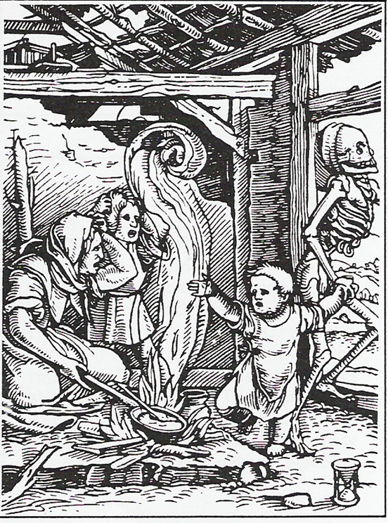
Source A: A 14th century German wood cut showing the Black Death

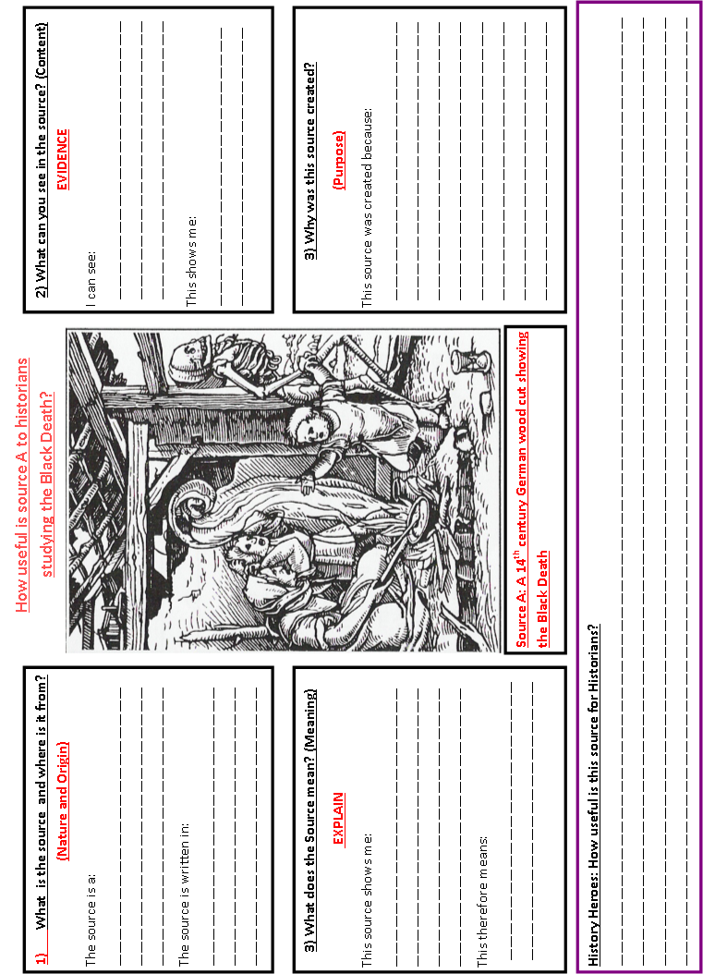
Task 4: Describe two features of the treatments people tried to cure the Bubonic Plague
Identify first feature:
_________________________________________________________________________________________________________________________________________________________________________________________________________________________________ Describe the feature by adding detail:
____________________________________________________________________________________________________________________________________________________________________________________________________________________________________________________________________________________________________________
Identify second feature:
_________________________________________________________________________________________________________________________________________________________________________________________________________________________________
Describe the feature by adding detail:
____________________________________________________________________________________________________________________________________________________________________________________________________________________________________________________________________________________________________________
History Heroes: Explain how effective the treatments were that people tried to get rid of the Black Death
________________________________________________________________________________________________________________________________________________________________________________________________________________________________________________________________________________________________________________________________________________________________________________________________________________________________________________________________________________________________________________________________________________________________________________________________________________________________________________________________________________________________________________________________________________________________________________________________________________________________________________________________________________________________________________________________________________________________________________________________________________________________________________________________________________________________________________________________________________________________________________________________________________________________________________

Review: summarise what you have learnt in today’s lesson by adding to you “Brain dump” at the start of the lesson using a different colour pen if you can. If there is anything you are not sure on you can write some questions below and email them to your teacher for more help.

Lesson 4 – Consequences
LO: To explain the most significant factor affected by the Black Death

Background information:
As we know, the Black Death was a disease that effected a number of people. The precise effects are difficult to assess given the huge loss of life and the lack of records. In some places there was no one left to bury the dead let alone record the effects. However, historians have suggested the Black Death had a number of significant consequences. Estimates differ, but most historians believe that the Black Death killed half the population of Europe. In some places for example the village of West Thickly in County Durham, it killed everybody. The consequences can be grouped into the following factors:
- Social – To do with people
- Political – To do with the government or the running of the country
- Economic – To do with money
- Religious – To do with the Church
- Military – To do with wars and the army

Key Vocabulary
Consequence - a result or an effect of an action or an event
Tax – Money paid to the government that is based on your income
Significance - Something of extreme importance
Brain dump – Mind-map everything you can remember from last lesson, check your work before moving on.

Task 1: Below are several different consequence cards. Your task is to categorise them in to the factors in your table. Once you have done that, highlight all positive consequences in one colour and the negative consequences in another. One has been done for you.

About 33% of Wales and England’s population died. It took 250 years for the population to recover. | New medical discoveries and artistic ideas would later bring about a rebirth of culture. | Less tax meant Kings had to think twice before going to war as it was too expensive. So, tax increased a lot.
New religious groups were set up, e.g. the Lollards who criticised the Catholic Church. | Creative works (paintings, murals etc) became morbid, with the image of death everywhere. | Many Churches closed down. It was hard to find enough people to take over the jobs of priests.
The feudal system collapsed. Peasants could leave their village to find work’ land and freedom elsewhere. | Wages increased by 400% after the disease. Workers could demand more as fewer of them were alive. | Some villages, like Wharram Percy, never recovered from the disease, and were left abandoned.
Women had new job opportunities. | Poor people’s clothing improved. | Poor people’s diets improved.
Peasants’ attitude towards authority changed. They believed they could stand up to authority as God had spared them. | Some people thought the disease could return any day, so they lived a wild life. They drank, threw parties and lived carelessly. | Medical knowledge improved as doctors were allowed study corpses. People began to understand how the human body worked.
Lords saw the value of their land decrease. They lost a lot of money. | Harsh laws tried to stop the freedom and improvements of peasants’ lives. | Officials slowly realised that towns and cities had to be cleaner in future.

Social  To do with people… | Political  To do with running the country… | Economic  To do with money… | Religious  To do with the church… | Military  To do with wars and the army…
About 33% of Wales and England’s population died. It took 250 years for the population to recover.

Task 2: Reflect - Complete the Multiple choice questions
What are the 5 factors that the consequences can be categorised in?
Social, Economic, Political, Military and Science | Social, Economic, Political, Military and Religious | Social, Economic, Political and Military
What is one positive consequence?
A huge majority of the population died. | Peasants gained more freedom. | Rich people’s diets improved.
What is one negative consequence?
Harsh laws were put into place to limit people’s freedom | Lords gained a lot of money from the land | Women had less opportunities
How did the Black Death affect religion?
New religious groups were set up. | People lost faith in God. | Churches closed down.

Task 3: As you can see, the Black Death affected many aspects of life, but which factor did it affect the most? Place all five factors (Economic, Political, Economic, Military, and Religious) around the significance meter to work at the most significant factor affected. Explain your reasoning as to why you have placed the factor there.

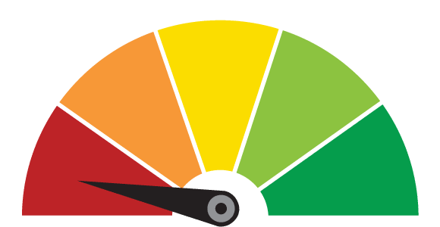
Most significant
Least significant
Some significance

Task 4: Explain the most significant factor that was effected by the Black Death the most
Structure and Sentence Starters
Identify – Make your point by identifying the most significant factor (use your significance metre)
In my opinion, the Black Death had the most significant impact on…
Describe - Describe the effects/impact of the Black Death on this category/factor (use the consequence cards)
The Black Death had a significant impact on the Economy as it…
Explain why the factor you have chosen was the most significant one.
The economic factor was the most significant one and the most affected by the Black Death because...
__________________________________________________________________________________________________________________________________________________________________________________________________________________________________________________________________________________________________________________________________________________________________________________________________________________________________________________________________________________________________________________________________________________________________________________________________________________________________________________________________________________________________________________________________________________________________________________________________________________________________________________________________________________________________________________________________________________________________________________________________________________________________________________________________________________________________________________________________________________________________________________________________________________________________________________________________________________________________________________________________________________________________________________________________________________________________________________________________________________________________________________________________________________________________________________________________________________________________________________________________________________________________________________________________________________________________________________________________________________________________________________________________________________________________________________________
Review: summarise what you have learnt in today’s lesson by adding to you “Brain dump” at the start of the lesson using a different colour pen if you can. If there is anything you are not sure on you can write some questions below and email them to your teacher for more help.

